**CloudFormation**: AWS do IaC using CloudFormation.

**CloudFormation, stack, templates, resources, Parameters (dynamic input can defined of which type, about as description), mapping (static variables), Output (Reference to what has been created), Condition (list of conditions to perform resource creation), Metadata, Reference (to refer a parameter value using !Ref), conditions, Rollbacks (for create and update both, having policies to modify), Nested Stack (to reuse components to use them in another teplates), StacSets (To do an operation for multiple Stacks(from multiple regions, accounts), managed by root account)**

**(AWS :: product name :: data-type-name) = To create a resource**

**intrisic functions:**

**!Ref = to refer to a paramter or resource**

**Fn :: FindInMap = to use/access mapping value**

**Fn :: ImportValue = to import value/output of another template's variable into current template**

**Fn :: Sub = substitute variable from text**

**Fn :: And, Fn :: Equals, Fn :: If etc.**

**IaC**: **Infrastructure as code** (IaC) is the process of managing and provisioning computer data centers through machine-readable definition files, rather than physical hardware configuration or interactive configuration tools. 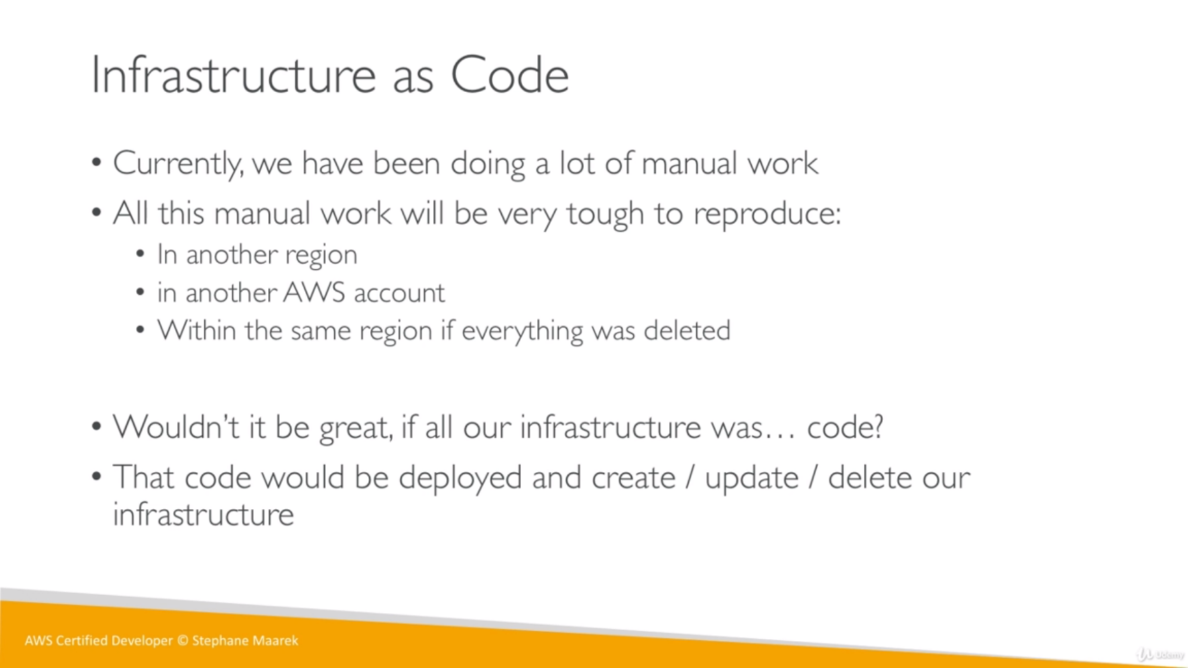

Till now, we have setup AWS infrastructure manually using AWS UI like creating an EC2 instance, security group etc., but all this can also be done using CloudFormation as IaC.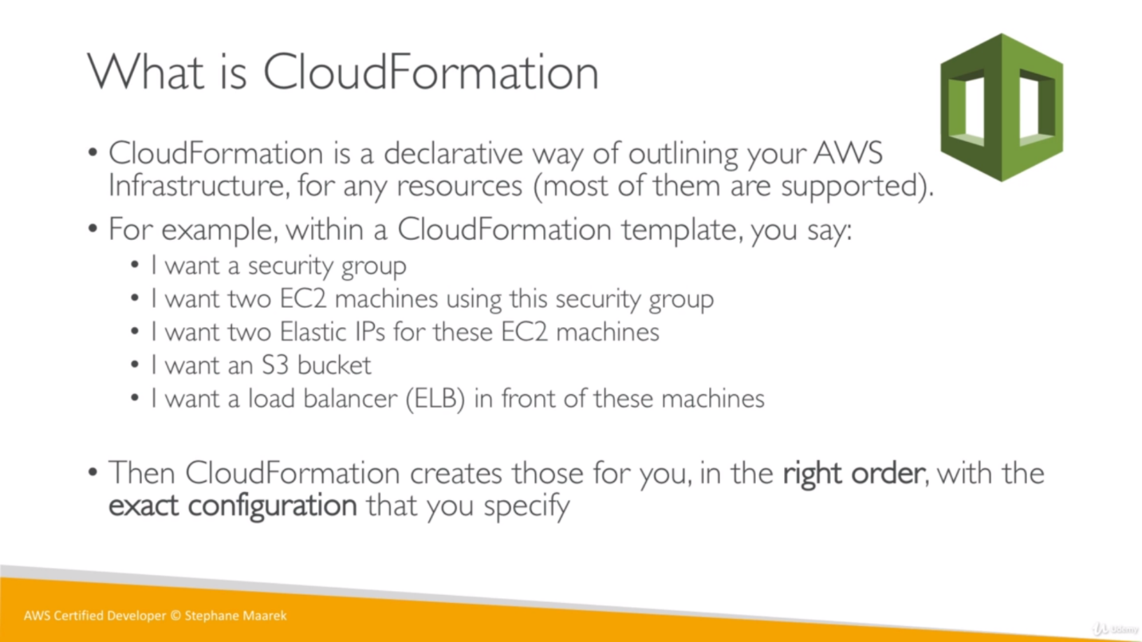

“Imperative programming is like **how** you do something, and declarative programming is more like **what** you do.” So Declarative way mean we just define what to do not how to do.

**Stack**: A stack is a collection of AWS resources that we can manage as a single unit. In other words, we can create, update, or delete a collection of resources by creating, updating, or deleting stacks. All the resources in a stack are defined by the stack's AWS **CloudFormation template**.

A stack, for instance, can include all the resources required to run a web application, such as a web server, a database, and networking rules. If we no longer require that web application, you can simply delete the stack, and all of its related resources are deleted.

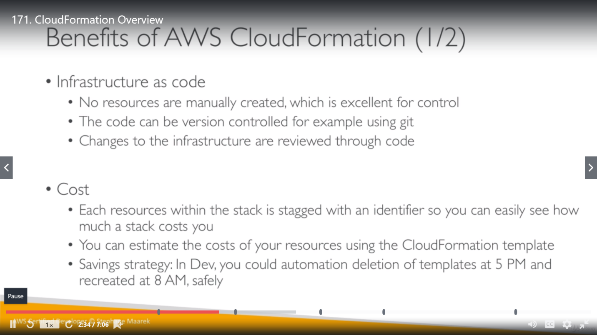

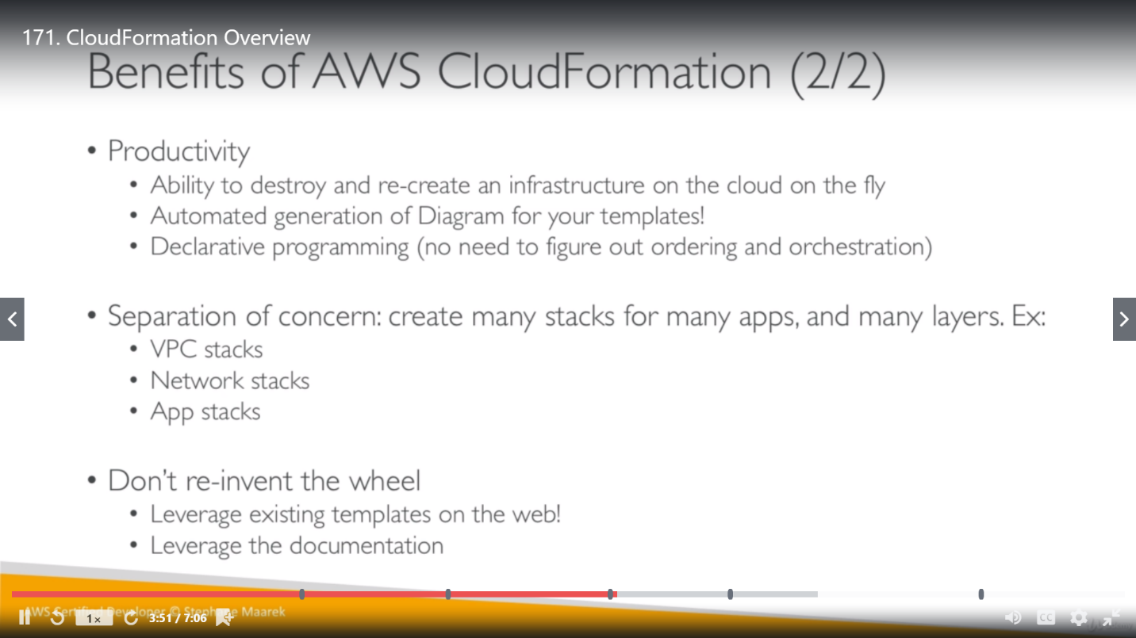

So, if we had a Stack which was having few EC2 instances, security group, ALB and ASG. Now if we delete this stack, all these resources will also be deleted in one go, we no need to delete them manually.

**Template:**  Templates are formatted text files in JSON or YAML. These templates describe the resources that we want to provision in our AWS CloudFormation stacks.

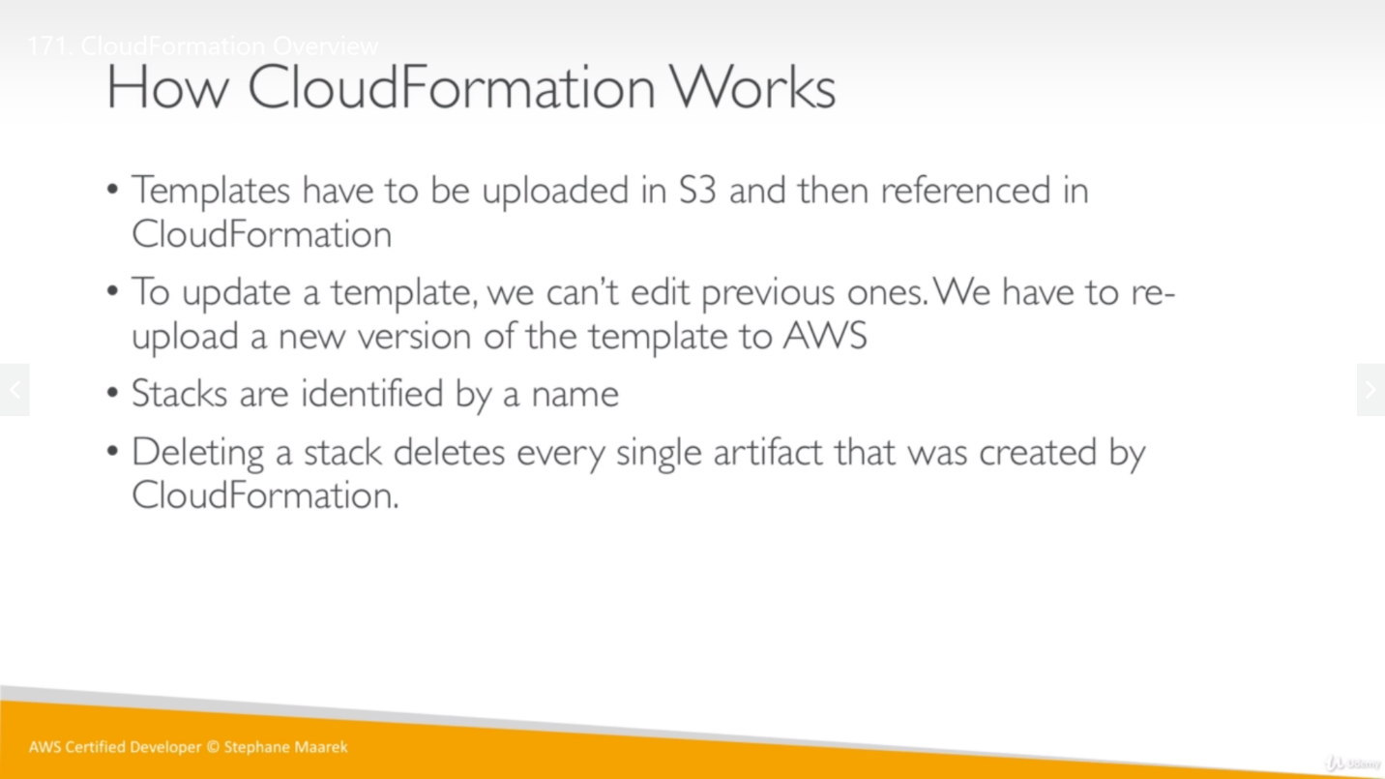

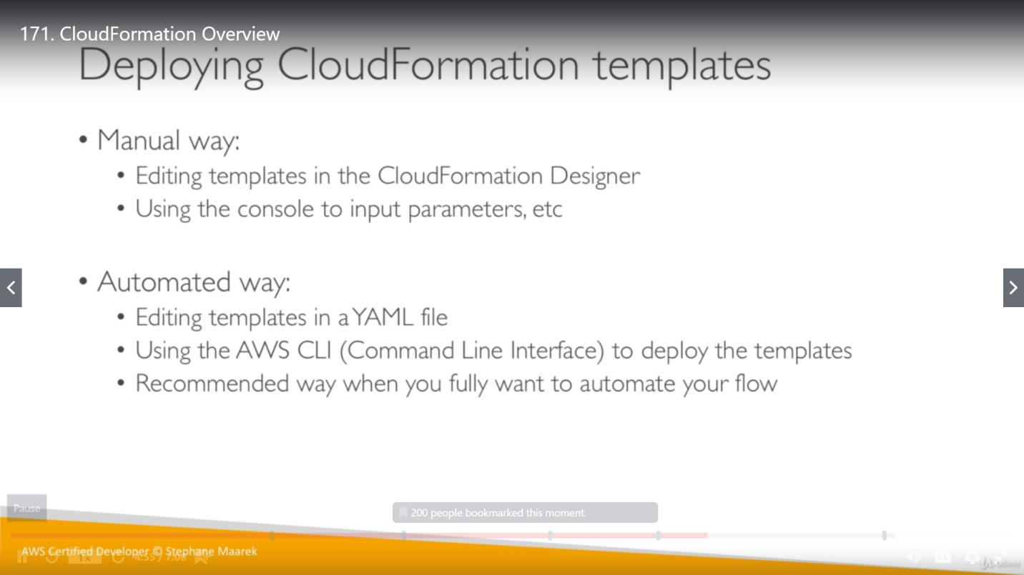

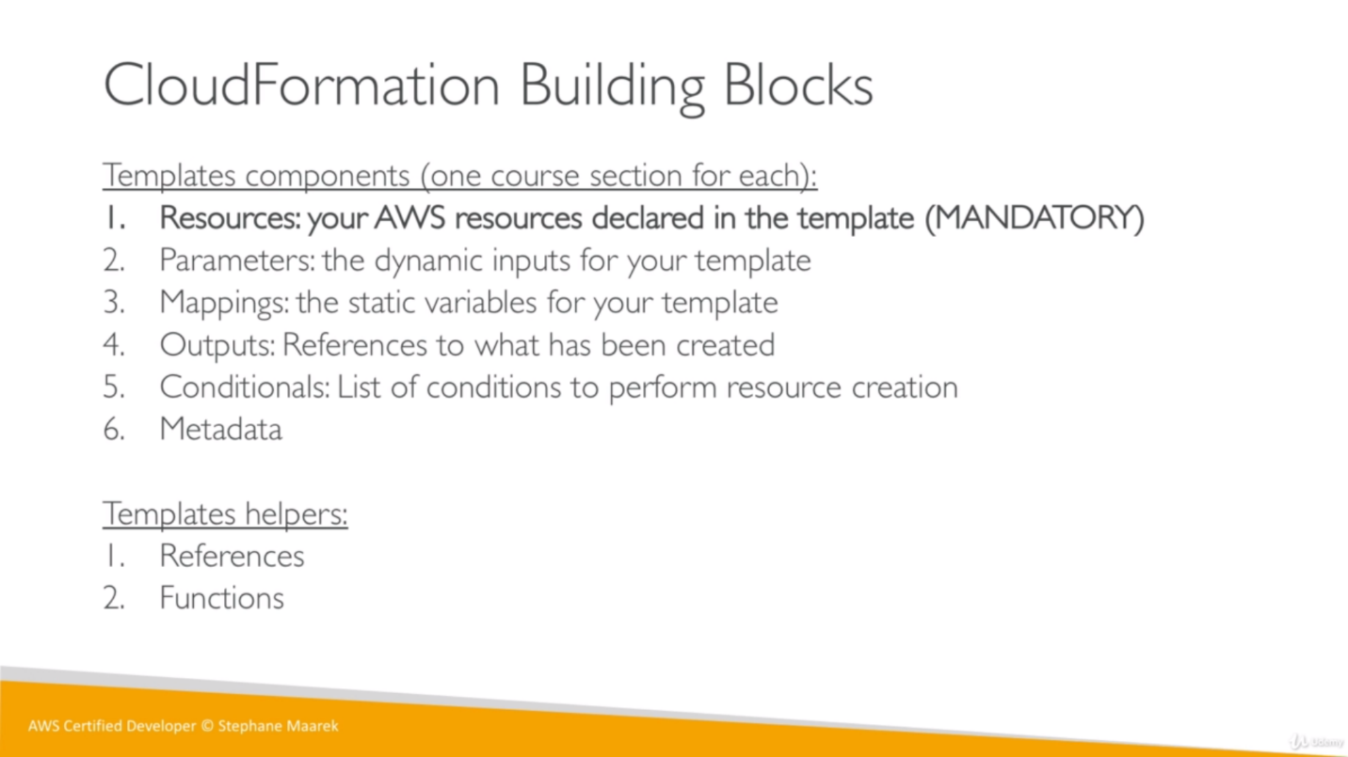

Templates can be written in JSON or YAML. We can get a pictorial representation of the resources mentioned in template file. We can see below example for a sample stack where we are just creating an EC2 instance

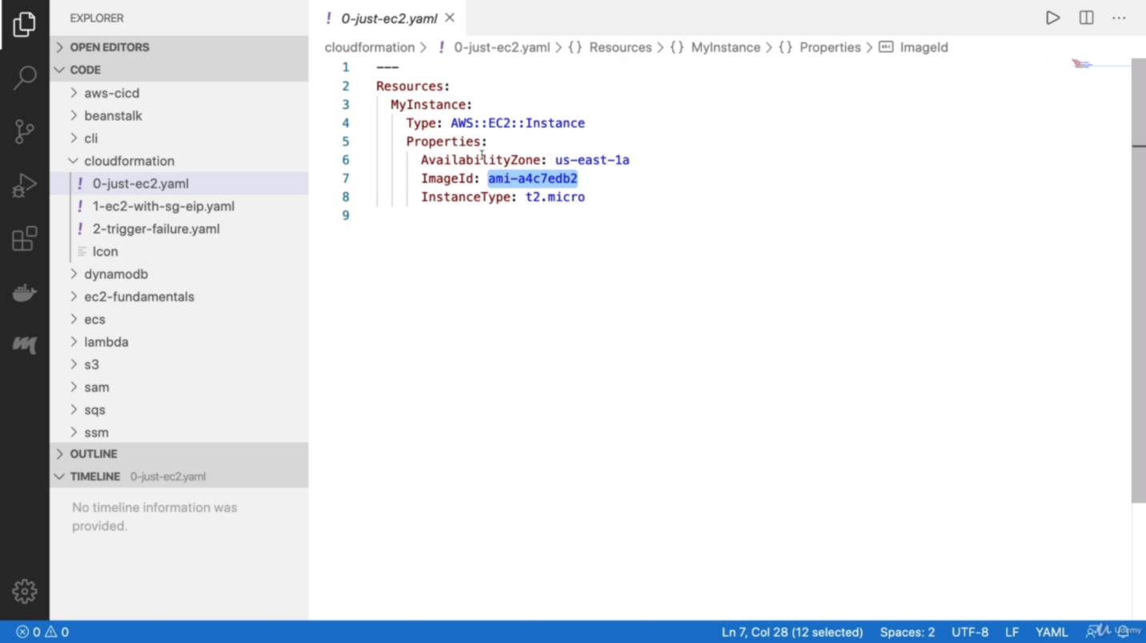

Once we create an stack, template can be modified but it can’t be modified after stack created, and we have below choices for same.

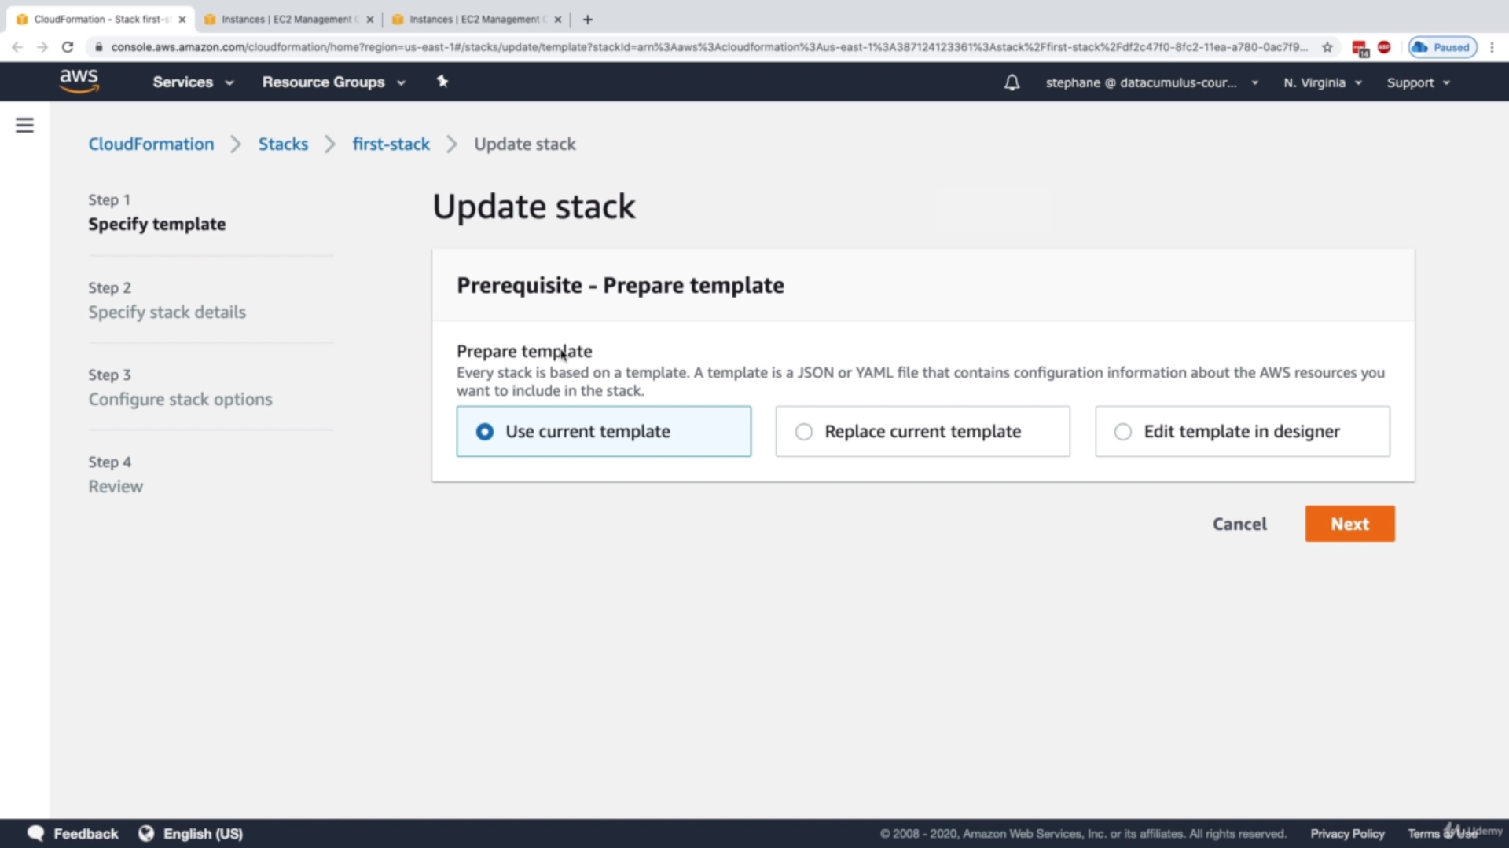

So, we have 3 options to update template as mentioned above.

If we don’t provide steps in Stacks in sequence, still CloudFormation find the order in which resources should be created/updated from template.

If we see stack’s Resources, we can get more information about the resources which were created from templates as EC2 instances URL, Security Group information etc.

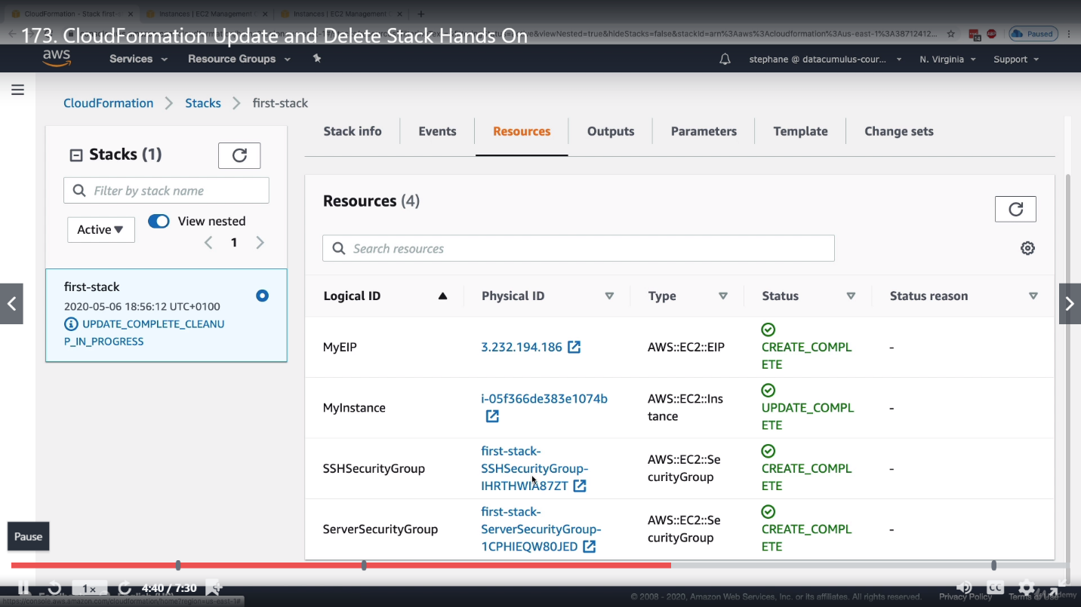

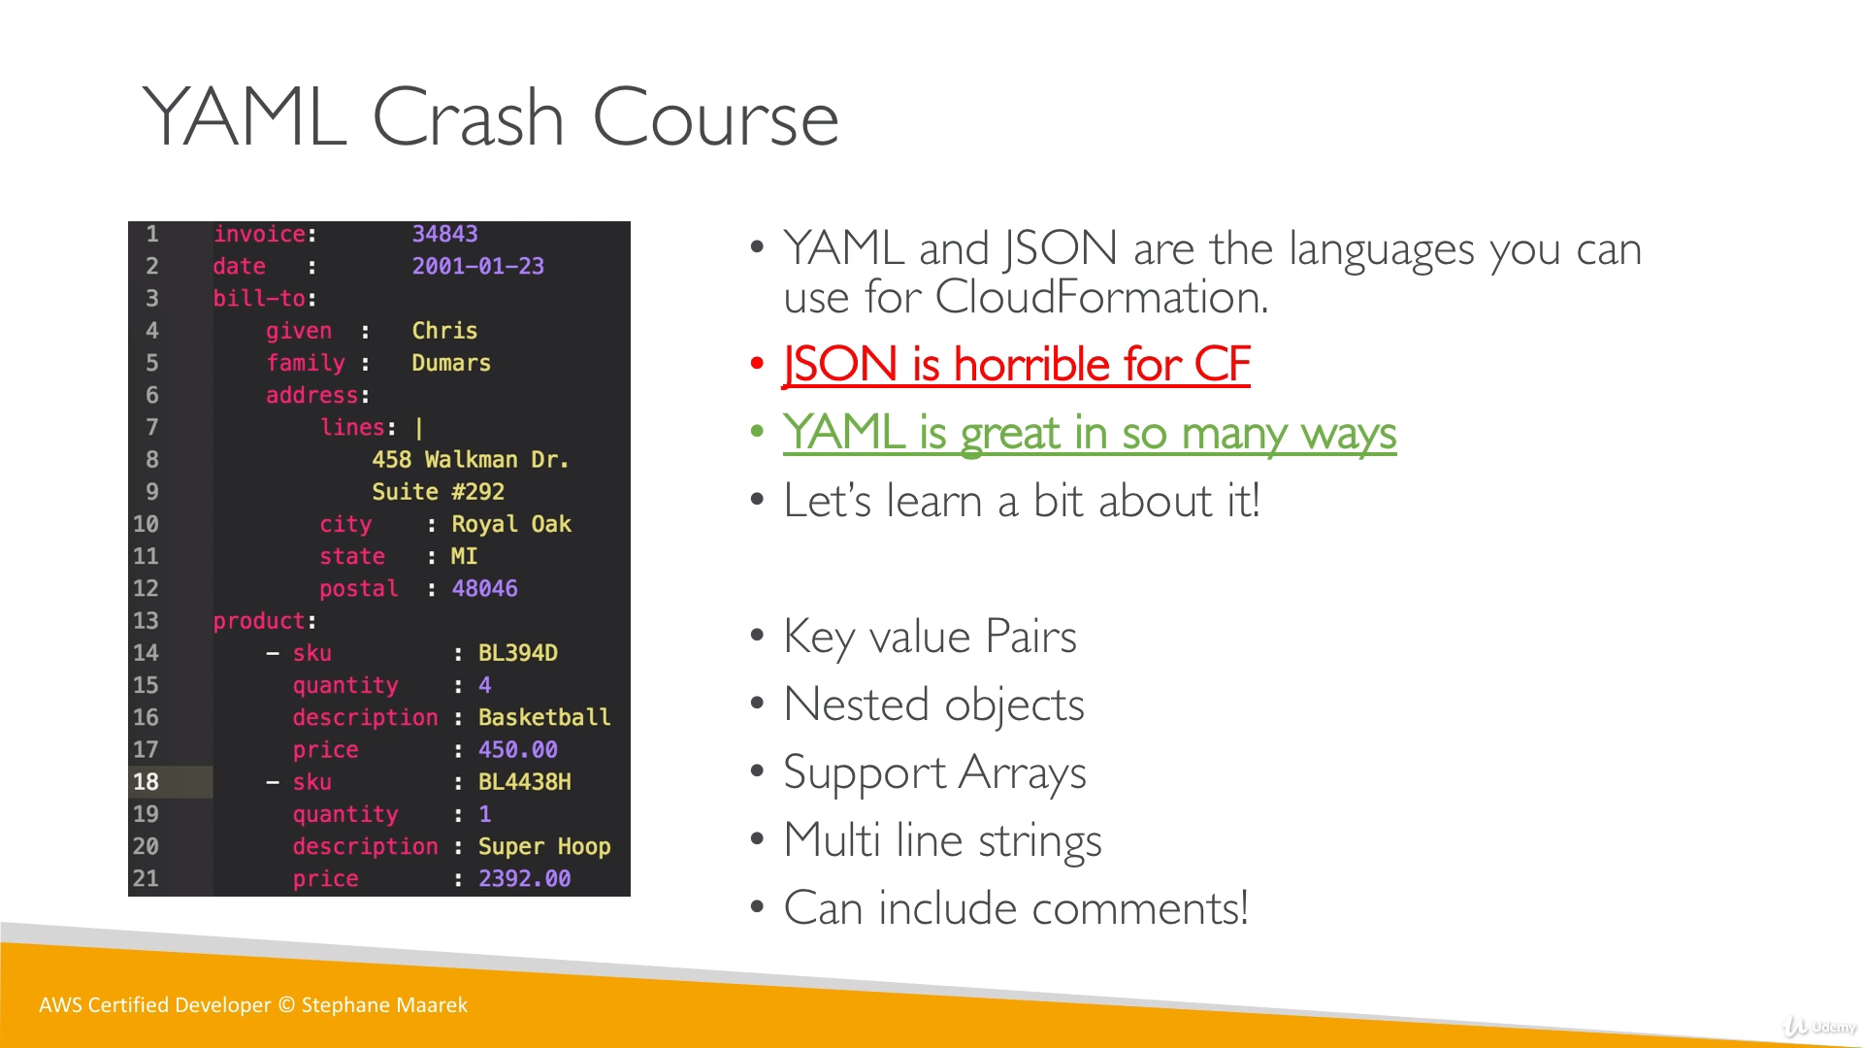

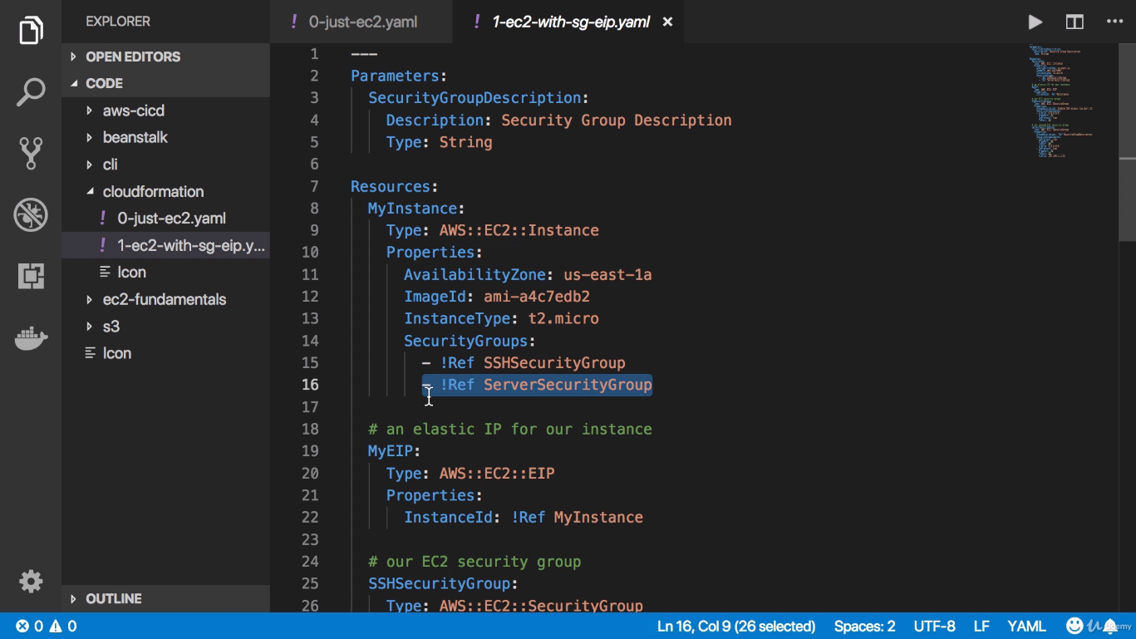

List is defined with a **“**–**”** sign as selected part in above example.

**Resources:**

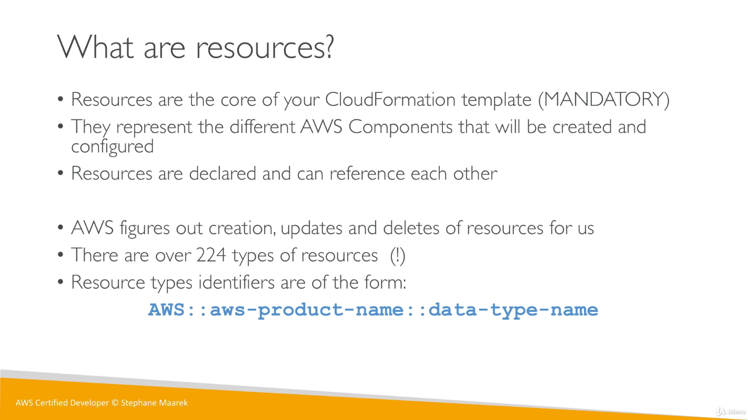

* So, for EC2 instance resource will be written as= **AWS :: EC2 :: Instance**
* For Elastic IP for an EC2 instance resource will be written as= **AWS :: EC2 :: EIP**

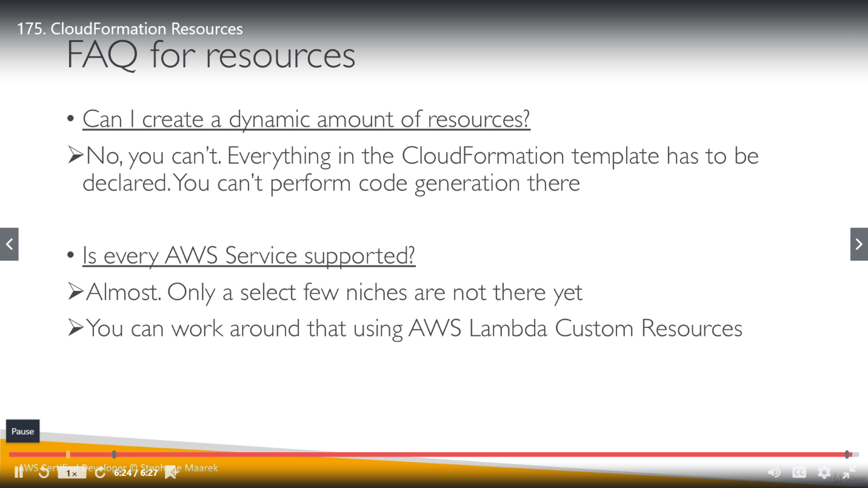

**Parameters:**

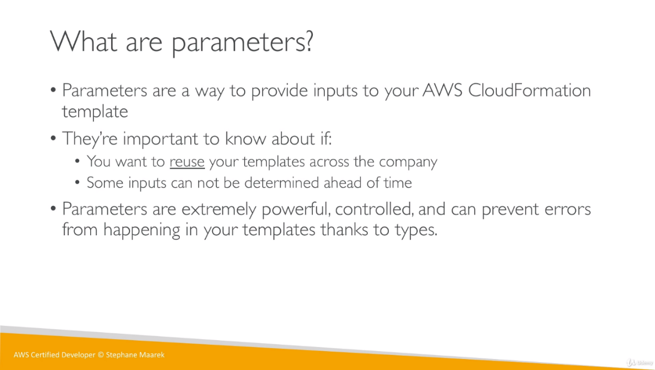

We have static data in templates but there can be few things which might need to update in future so we can define those things as parameters in template. We can have a maximum of 60 parameters in an AWS CloudFormation template.

We can set/update the parameters and this value will be used by Resources.

So, we no need to reupload templates for these changes.

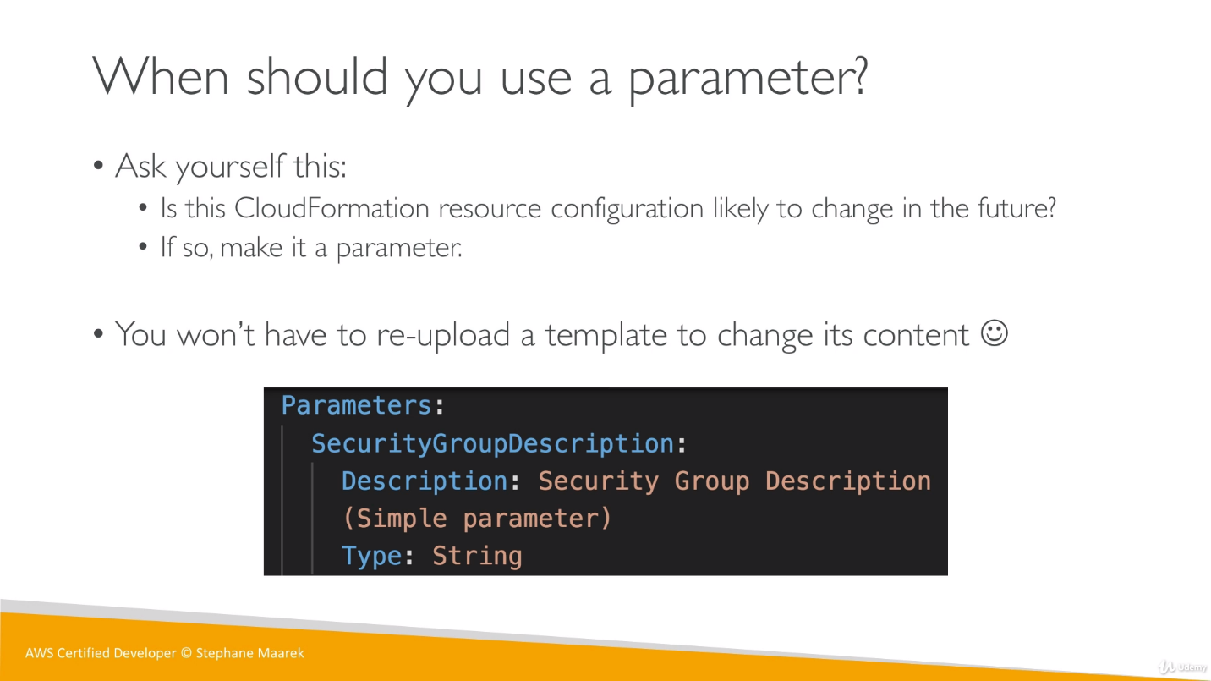

We have many settings related to parameter, just look it no need to remember all.

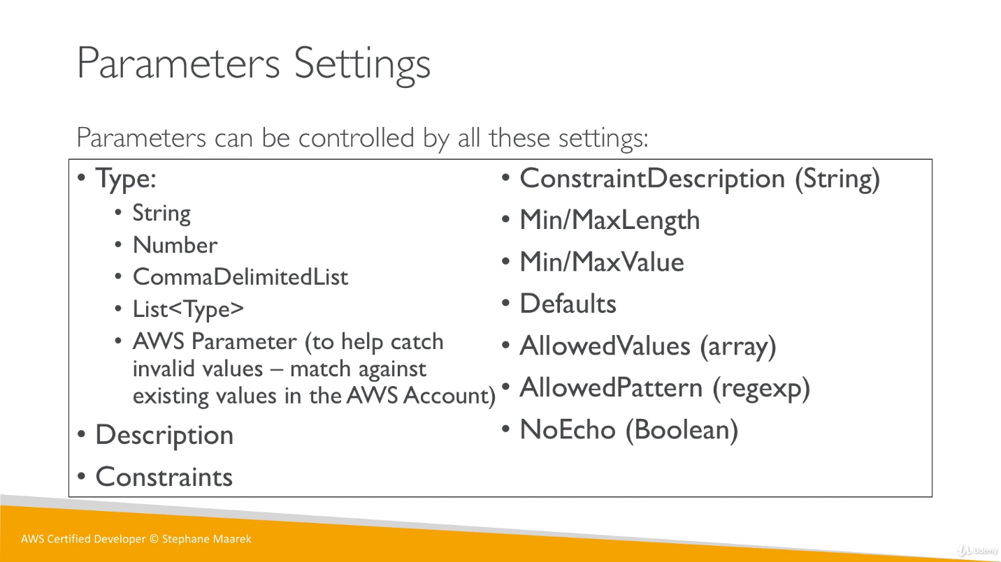

**Reference a Parameter:**

We can use a function called Ref to reference a parameter or a resource.

Whenever we want to use this function in our template, we can mention it either **Fn::Ref** or **!Ref** , both will give the same result.

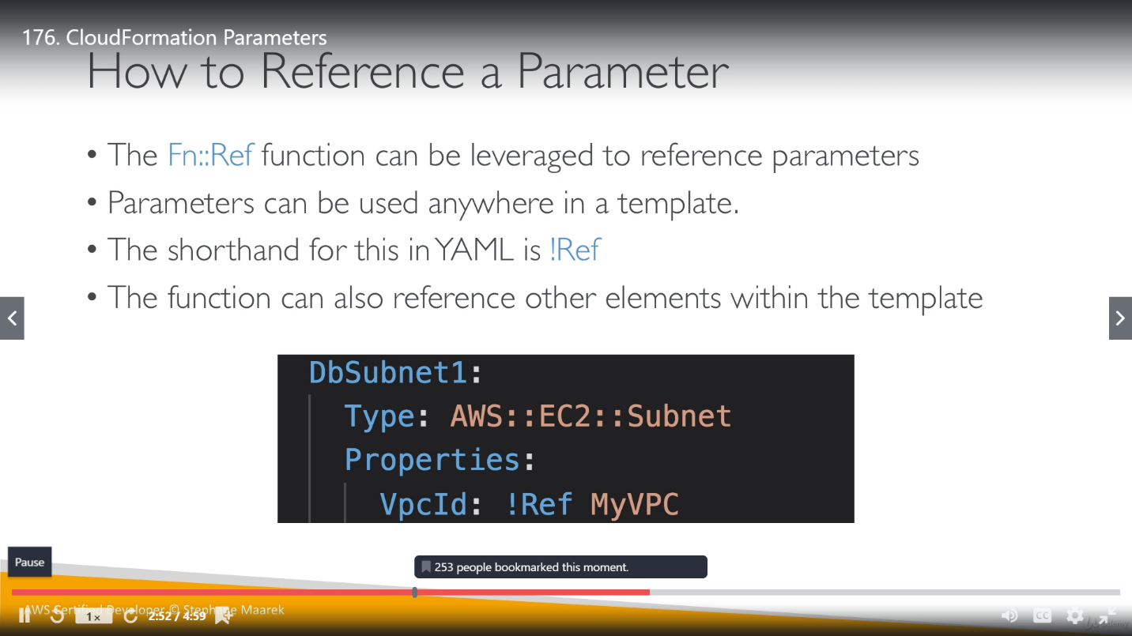

We can use Ref function within the same template as well. As in below example we have defined, SecurityGroupDescrition as a parameter and later use it in Properties.

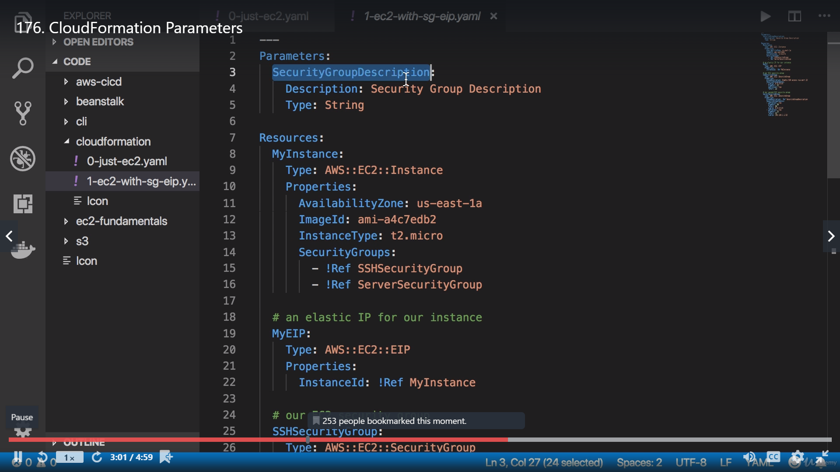

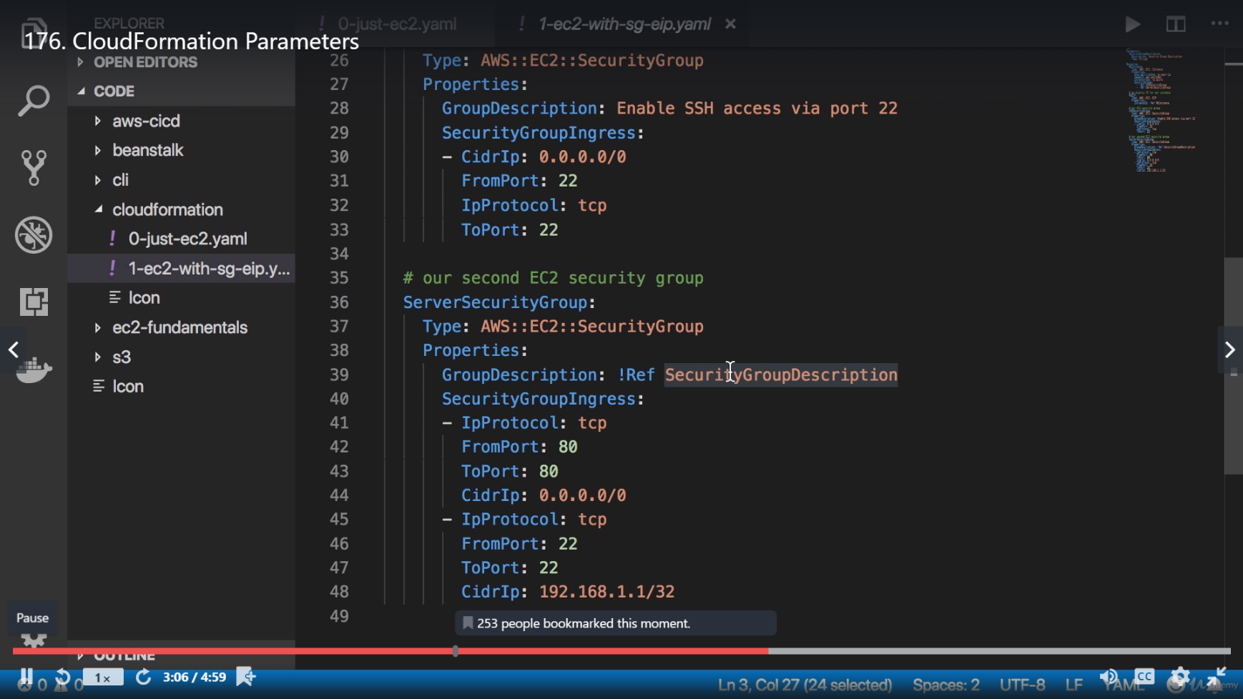

Ref can also be used for resources as well, mentioned in below example. Here SSHSecurityGroup was a resource used by SecurityGroup resources.

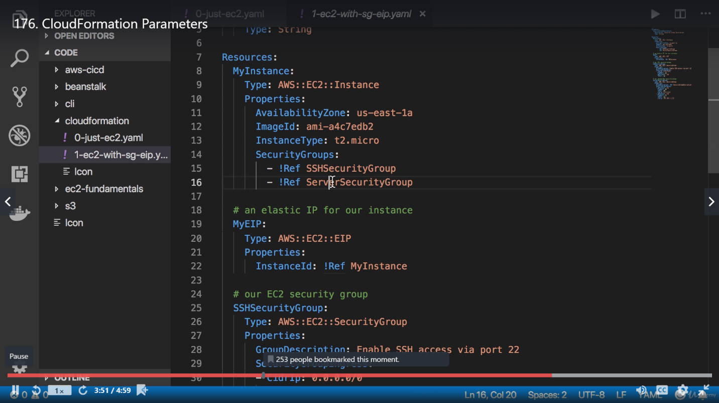

**Pseudo Parameter:** We have a similar concept of Pseudo parameter as Ref. Just not to be confused, they are somewhat similar to resource (**AWS :: EC2 :: Instance**) declaration in AWS but in resource we give a predefined product name(EC2 here) and data type name (Instance here). Pseudo parameter have any String along with AWS like AccountId as mentioned below.

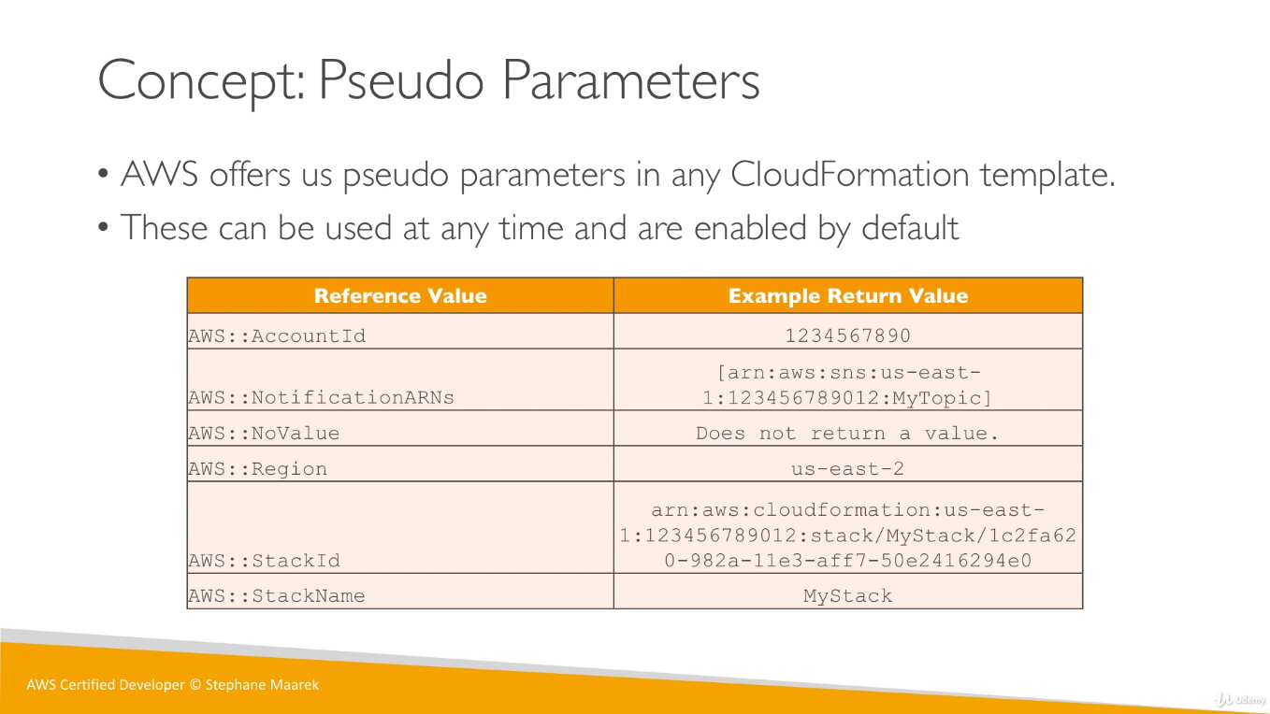

**Template Mapping:**

Mappings are fixed variables in our templates, they are hard coded.

Mappings: Mapping01: Key01: Key: value

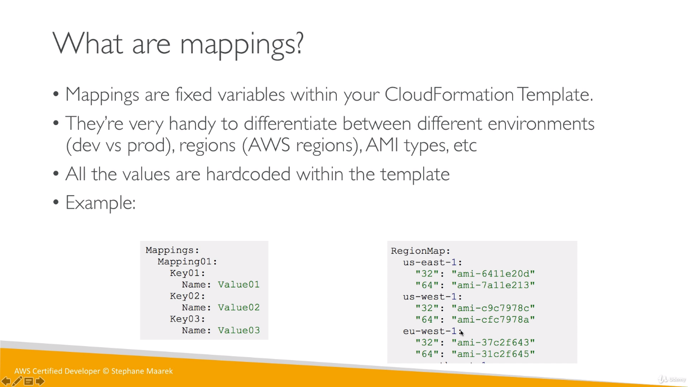

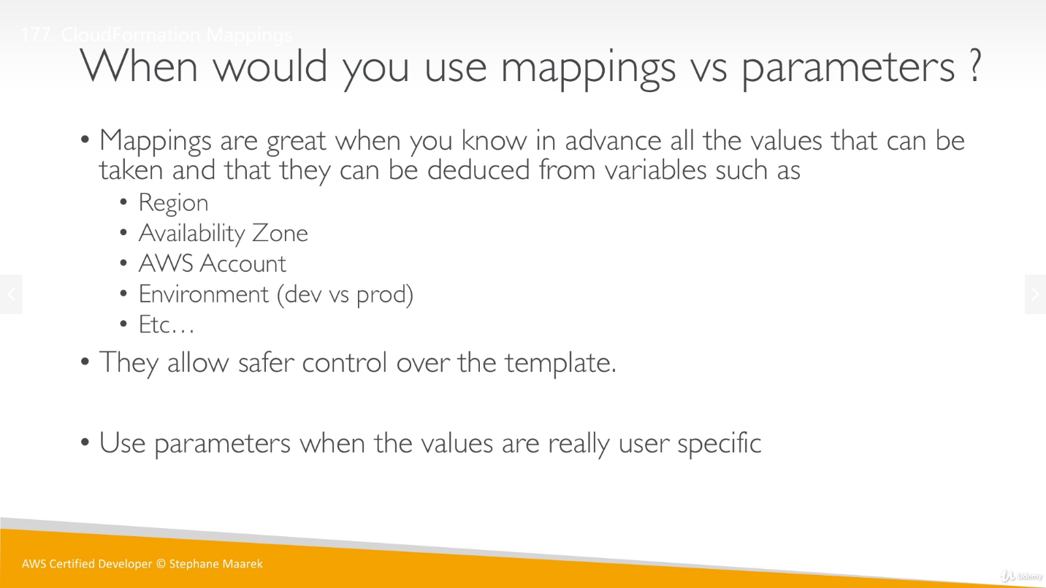

To access the mapping value, we have a function known as **Fn :: FindInMap**

We must use 3 parameters to FindInMap function to get any mapping value: MapName, TopLevelKey, SecondLevelKey

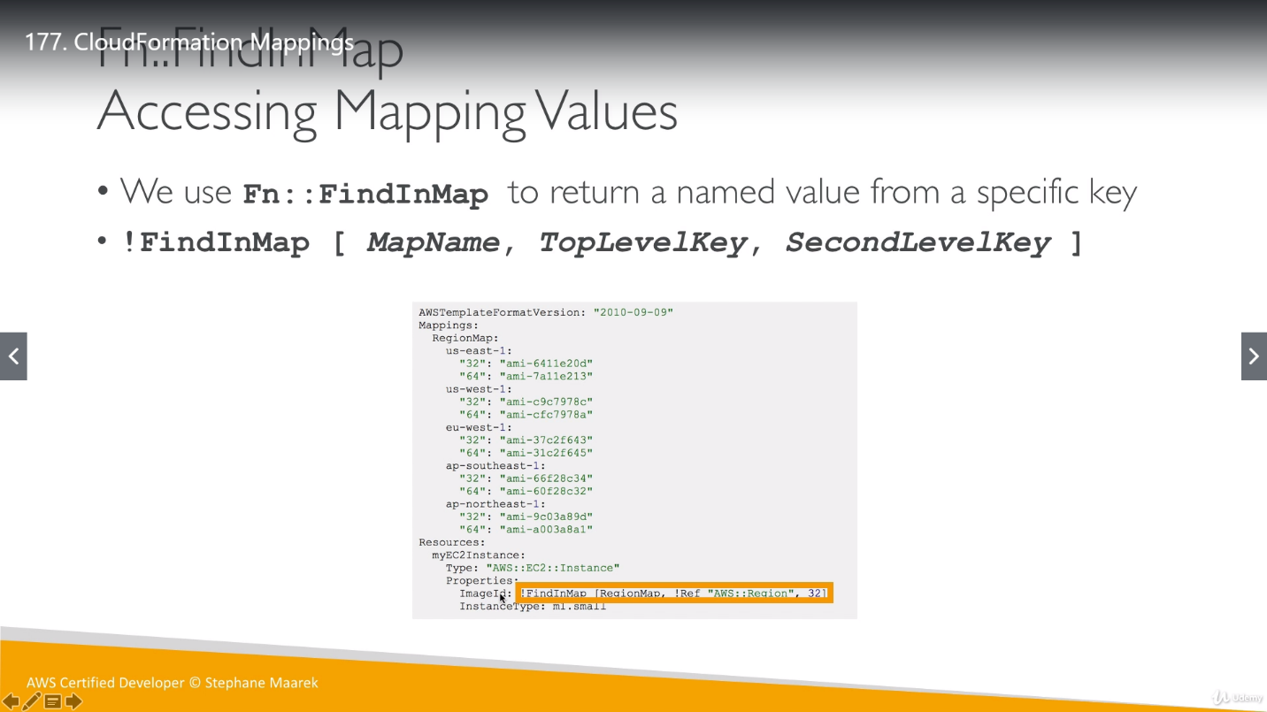’

**Output: **imp\*\***

We can use output of one template into another template. We have to first export the output of first template and later import into another template. Even though export is optional but if we want to use it in another template, we have to export it then only we can import it.

If we want to delete template1 then first, we have to delete template2 because it’s using output of template1.

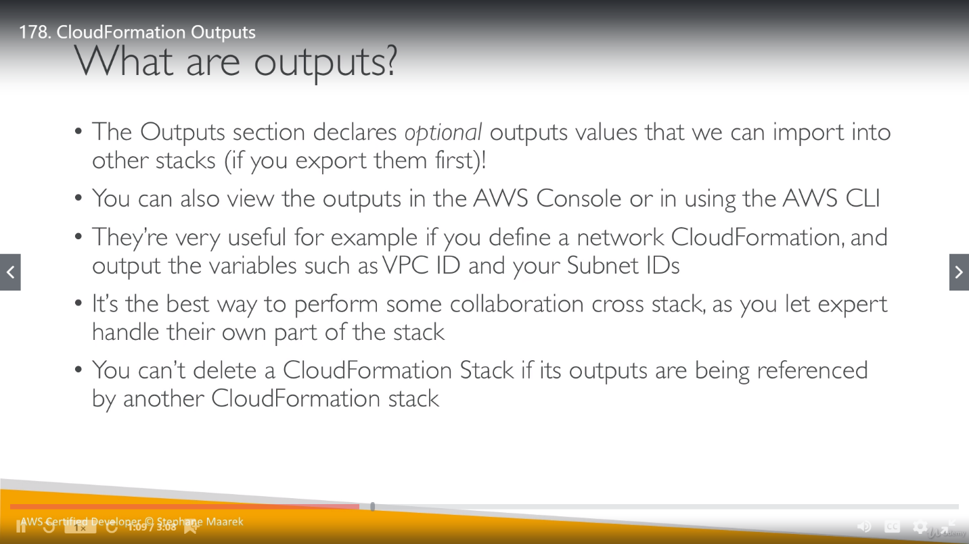

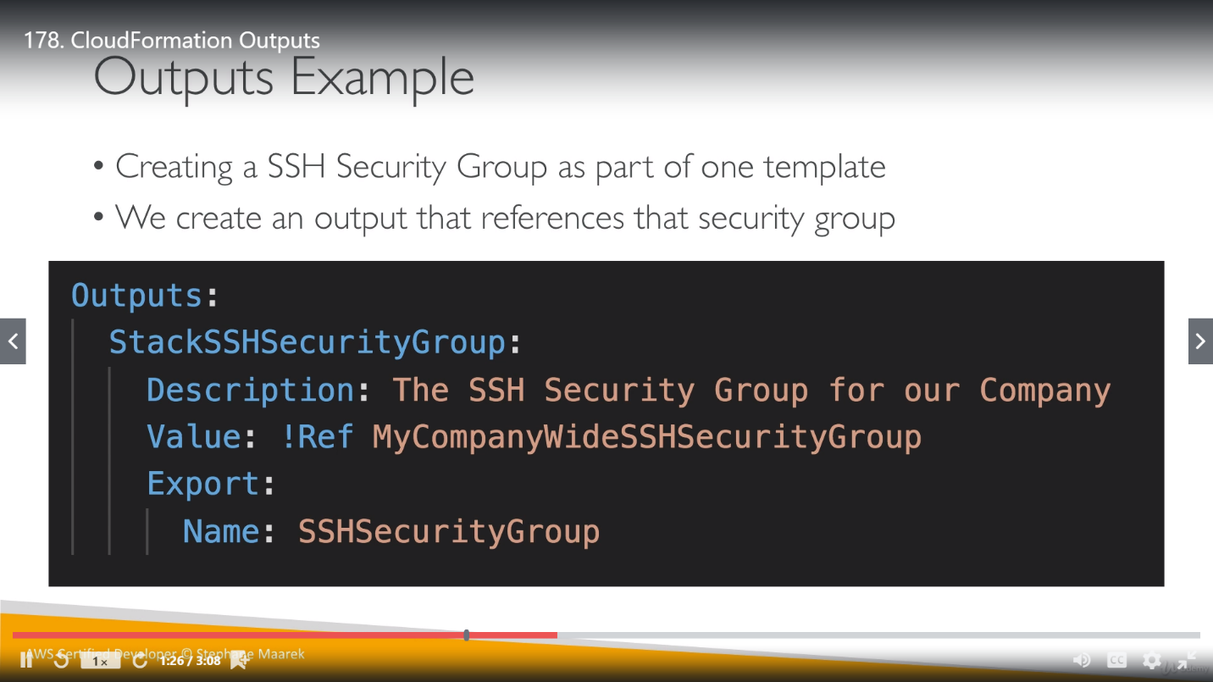

So here we are exporting output to use it in another template.

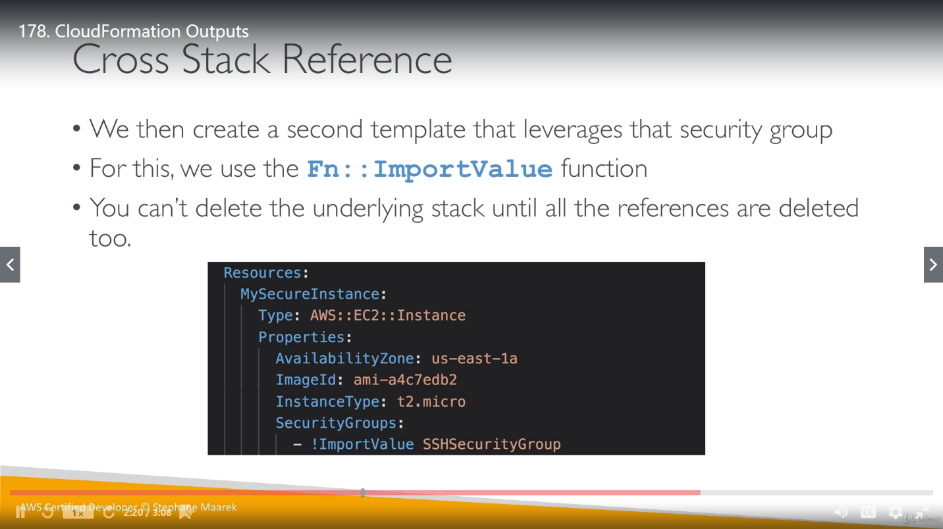

To import output of other templates, we must use a function **Fn :: ImportValue**

**CloudFormation conditions:**

Conditions are logical statements based on we control the creation of resources or get output. Two condition can use each other’s value using either parameter value (dynamic value) or mapping (static value).

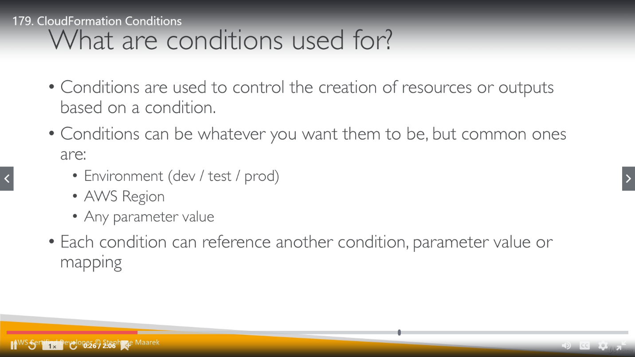

So, in below example, if value of EnvType is equal to prod (String) then only condition will satisfy.

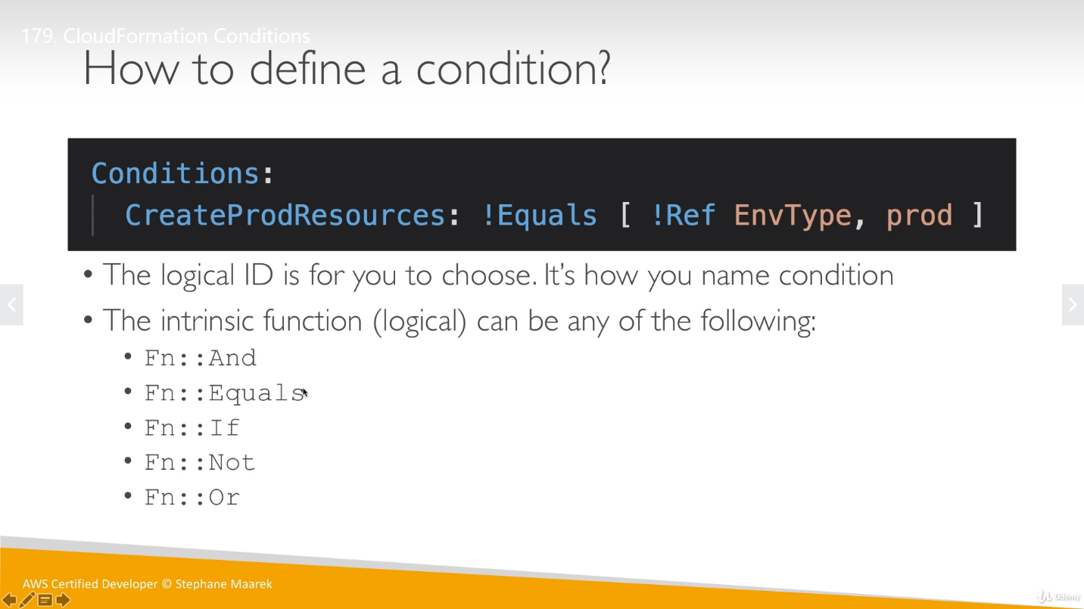

Condition can be applied on resources, output etc. So, in below example, MountPoint is only get created if mentioned condition is true.

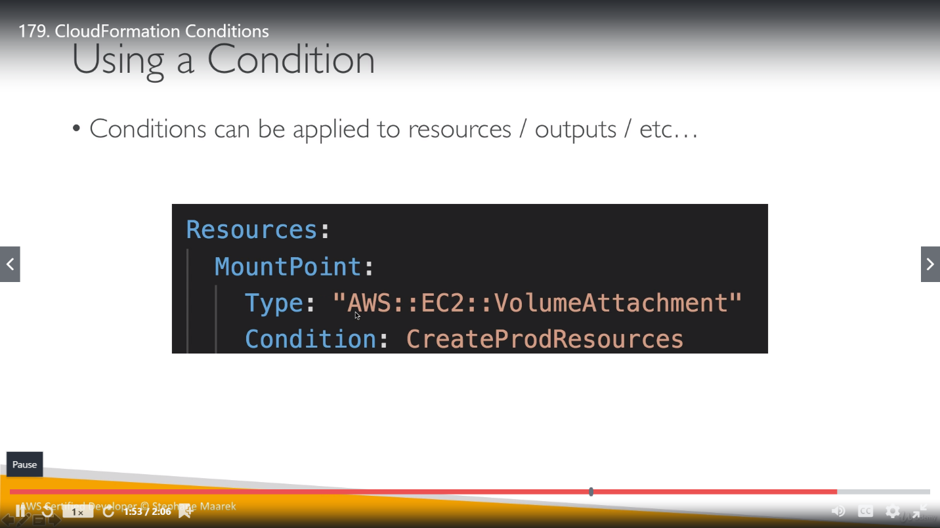

**Intrisic Functions:**

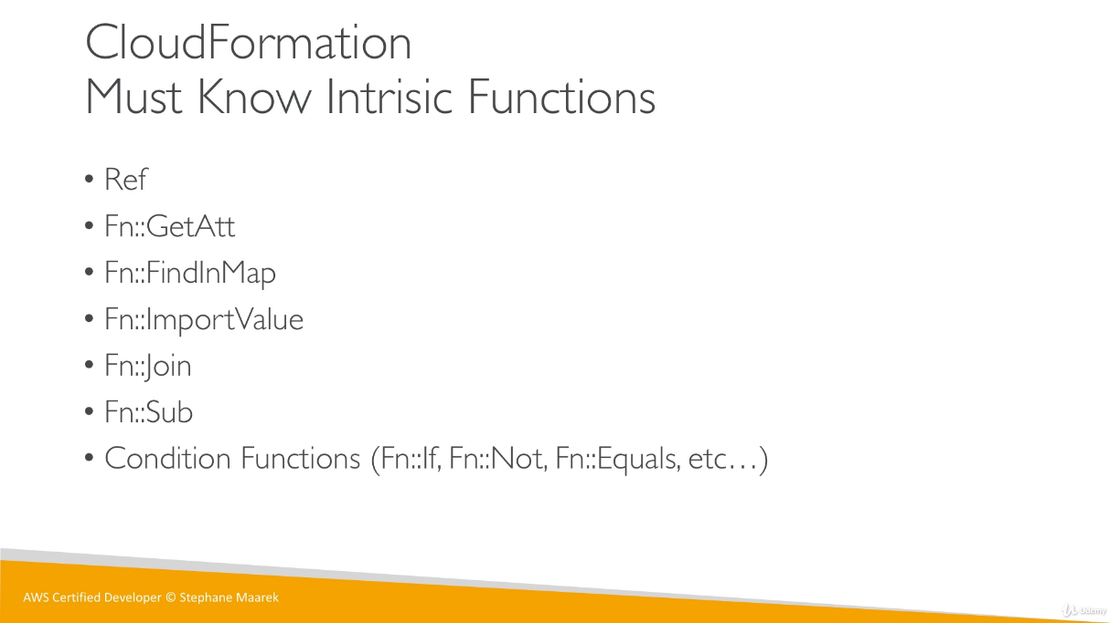

In !Ref, when we reference a resource it will return physical id of the resource.

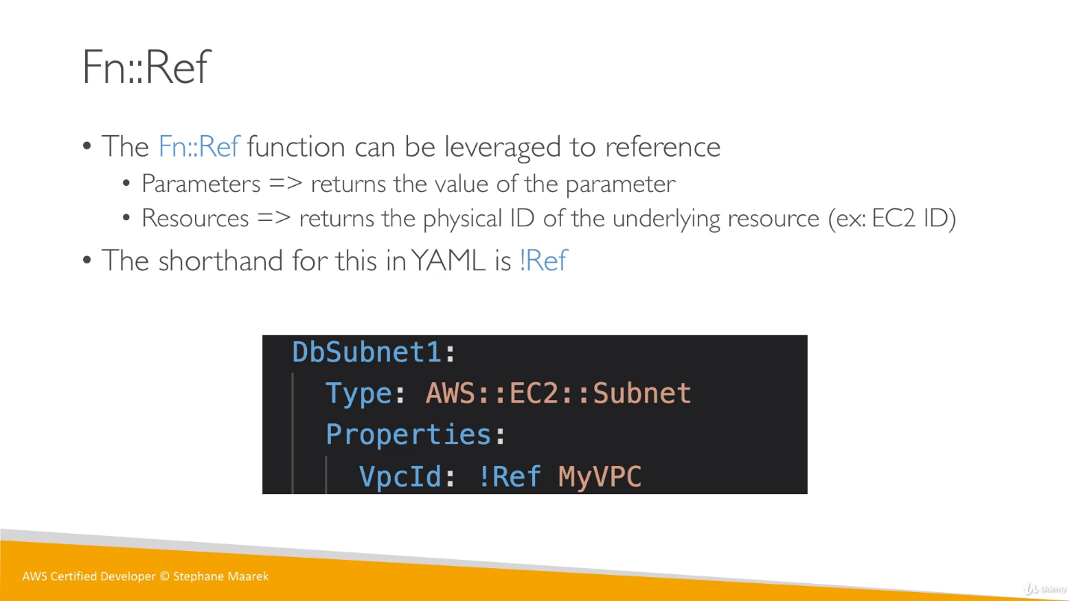

To get other information from the resources, we use **GetAtt** function. We will get all the attributes attached to a resource using this function.

We provide the attribute name along with GetAtt function to get its value.

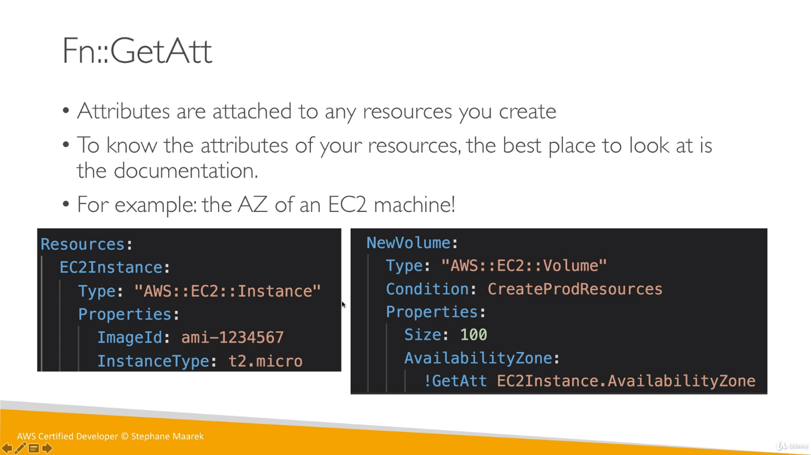

**Join:**

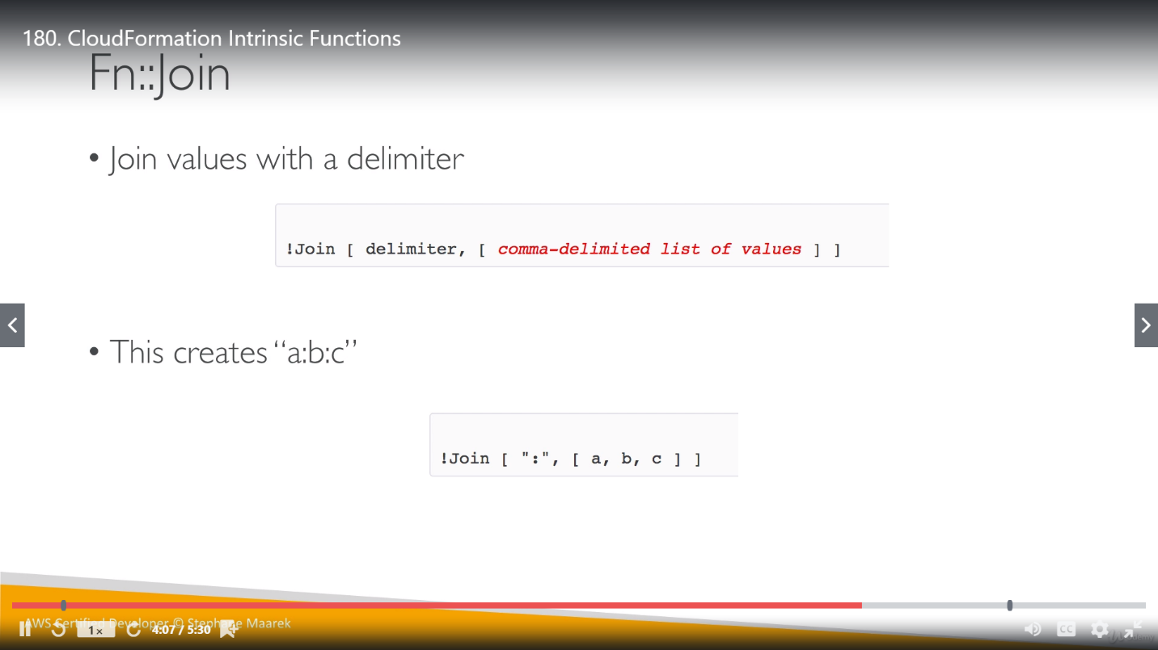

**Sub:**

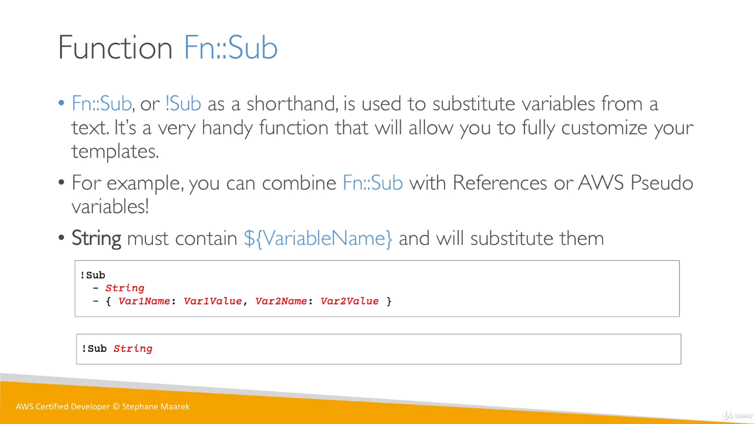

**CloudFormation Rollbacks:**

If something goes wrong while creating or updating Stacks, we have a feature Rollback to neglect the impact.

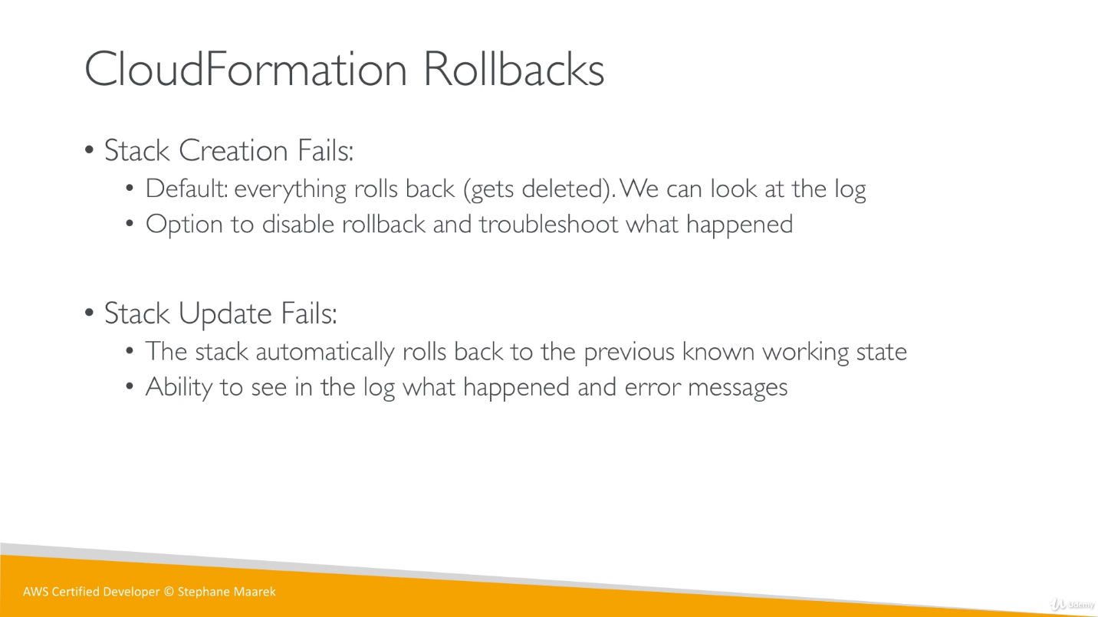

While create/update Stack, we have an advanced option to change Rollback policy

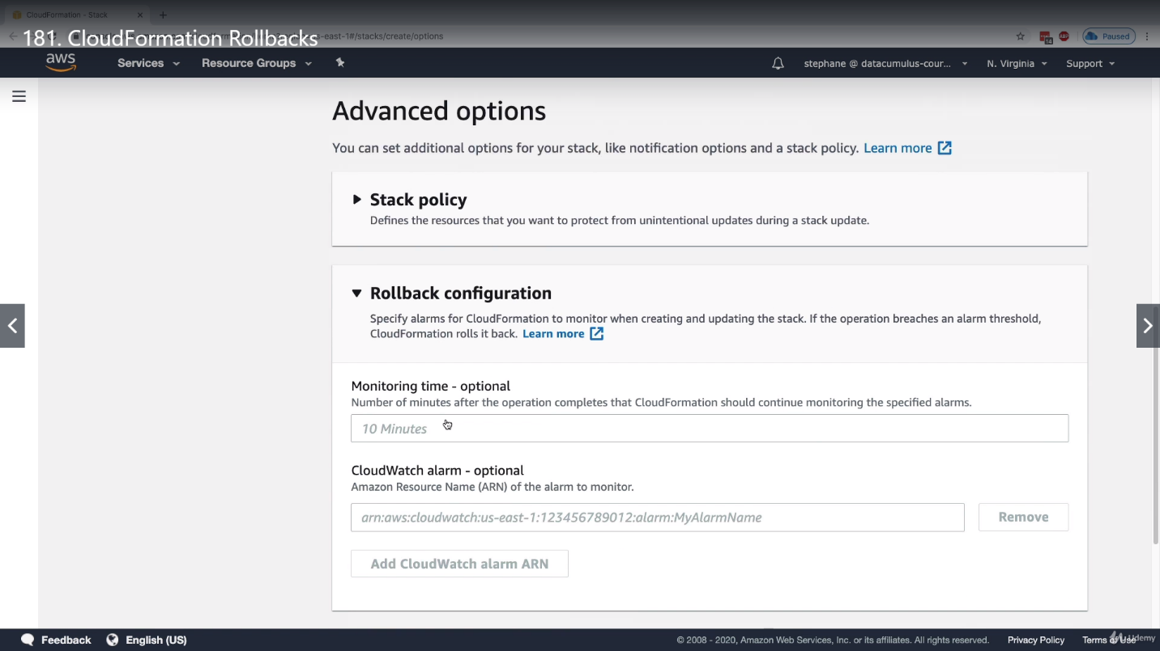

If rollback is disable, there won’t be any rollback so stack will be stuck and we troubleshoot it based on resources that have been already created.

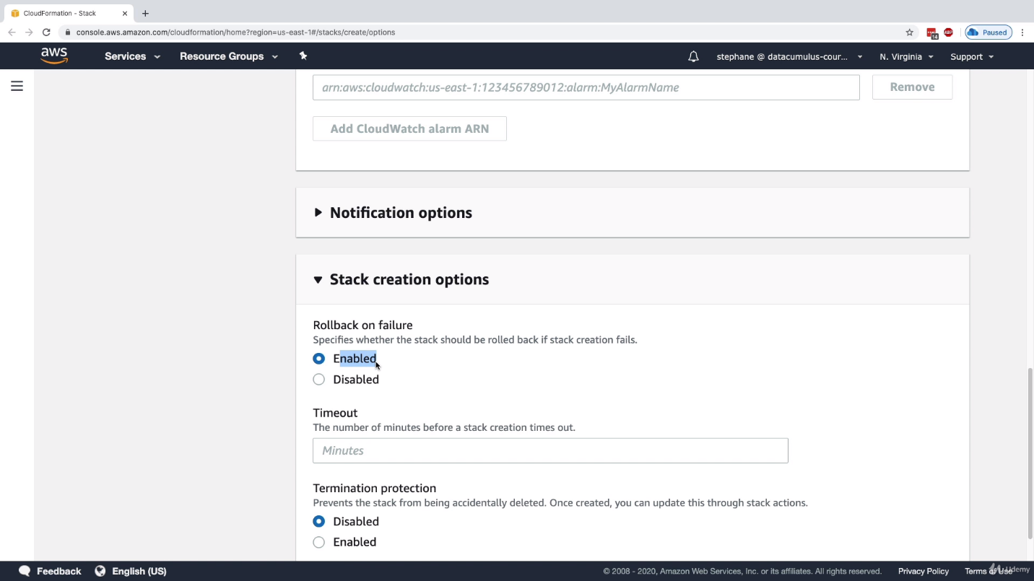

**ChangeSets :**

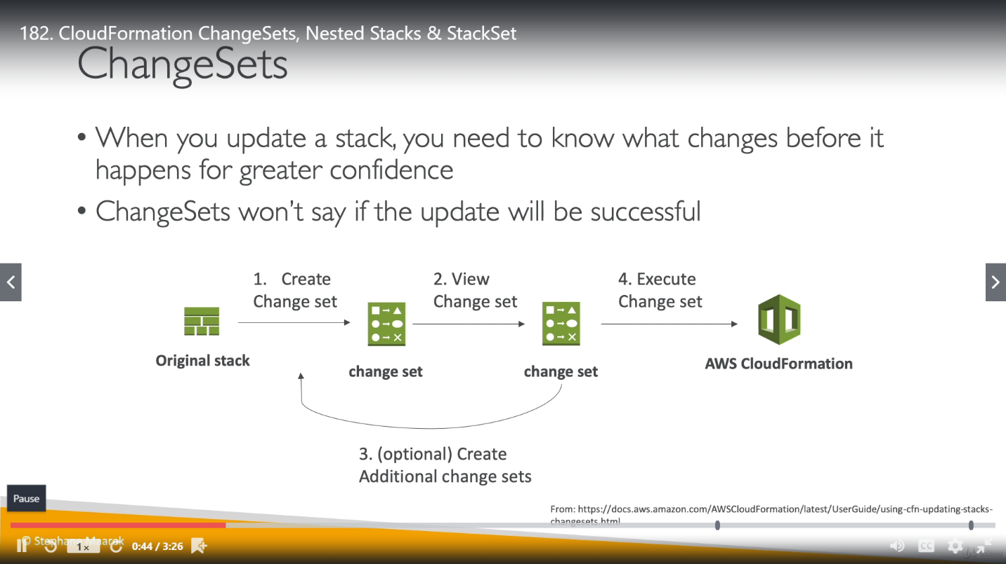

**Nested Stacks:**

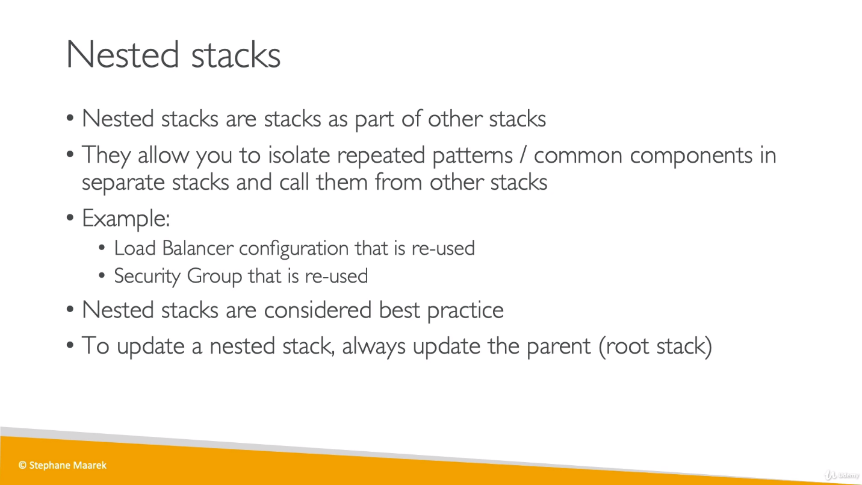

**Difference between Cross Stacks and Nested Stacks:**

**Cross Stacks:** when we use output of one template into another stack

**Nested Stacks:** when we need to re-use or re-create component to use them in another template then we can use Nester Stack.

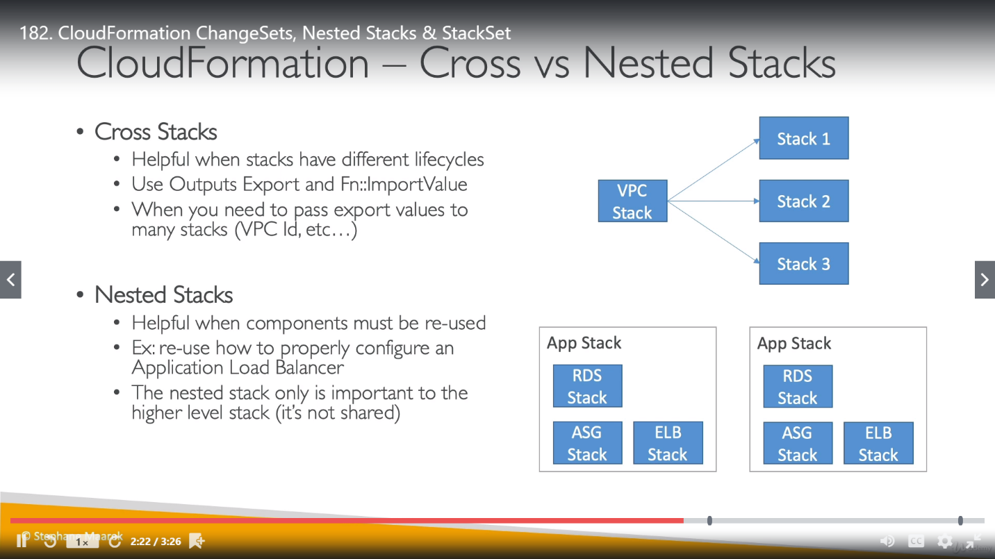

**StackSets:**

